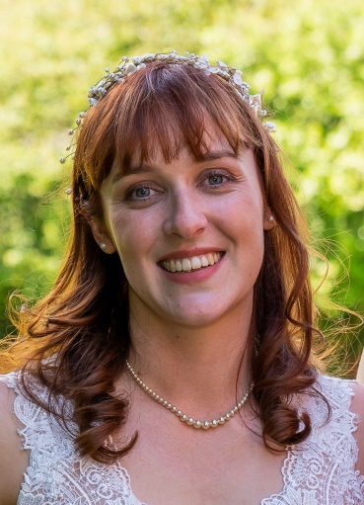
Sophie Brown
Operating Department Practitioner (ODP)
Theatres – The Walton Centre

Why did I choose to become an ODP?
After knowing from a young age that I wanted to work within Healthcare, I did what I could to find work experience or voluntary placements within different aspects of the healthcare sector before landing an opportunity to watch some surgical procedures. It was during this placement that I came across the ODP role, and all of its various aspects that I knew this was the job for me.

My current role and what it involves
In my current role I am a Scrub ODP; meaning I help the surgeon at the operating table by passing them the relevant equipment during the surgical procedures. I am also responsible for checking the instruments are in good working order, keeping count of all my sharps and swabs, and that we as a team, maintain a sterile field around the patient.

My journey up till now in my career
During my A Level studies I attended a Health and Social Care conference, which provided an opportunity to speak to people from different aspects of the healthcare sector. One workshop included looking at Orthopaedic Surgical Trays, and watching a video of a Total Knee Replacement. After speaking to the person in charge of the workshop, they invited me to attend the hospital for some experience in the department. Work experience then turned into a part time / weekend job as a Healthcare Assistant while I finished my studies, which then progressed into a full time job while I took a year out between finishing my A levels and starting University.

During university I attended different trusts to get experience in different specialities, before starting my full time ODP role in the Day Surgery Unit within a Major Trauma Centre. My role included Anaesthetics and Scrub predominantly with a couple of shifts in recovery as and when staff were required to provide extra help. I rotated regularly around my first trust experiencing the different specialities they provided. After 6 years, I wanted to develop my skill set further and decided that a move to The Walton Centre provided that opportunity.

The best thing about being an ODP, what makes it great?
For me it is providing the support and care to patients whom are going through a scary part of their life. It’s not normal to need a surgical procedure, because it means that something isn’t right, and that can be traumatic for the person experiencing it. Simply being there to provide a distraction from a cannula to holding their hand as they fall under general anaesthetic is quite rewarding.

An ODP is an invaluable member of the theatre team. They can help the Anaesthetist during the anaesthetic phase, and the Surgeon during the surgical phase, and the patient directly during the recovery phase. Being trained in all 3 areas of the operating theatres provides you with a variety of skills, so you can handle many different situations.

My advice about becoming an ODP

If you are looking into becoming an ODP, my main advice is to try and get work experience within the hospital theatre department. A theatre environment isn’t always calm, there are times when it can be stressful and is not for everyone.

