Applications open 30th October 2023 to January 5th 2024 | PWAP  Preston Widening Access Programme |  |  |  |  |  |  |  | January 2024 intake
PWAP is an award winning programme aimed at supporting students who aspire to enter the medical profession to attain a place on the Medical Undergraduate programme with The University of Manchester. The programme comprises of a range of activities and study which will support students to enhance their application to University. Students who have a WP flag and successfully complete PWAP and apply for the Medicine programme may be eligible for the following benefits;  Lower academic entry criteria:  A minimum of 6 GCSEs at grades A*/A with a minimum ABB prediction at A-level.  A lower UCAT threshold:  PWAP applicants must score in the top 75% of scorers with their overall UCAT score and not have a band 4 SJT.  Guaranteed interview:  Only if the above UCAT criteria has been met.  Lower offer grades:  if successful at interview, based on meeting the required contextual criteria  PWAP is recognised by UKWPMED, a collection of medical schools that recognise each other's access programmes.  The University of Manchester is Britain’s largest University, with a distinguished history of academic achievement and an ambitious agenda for the future. |  |  |  | 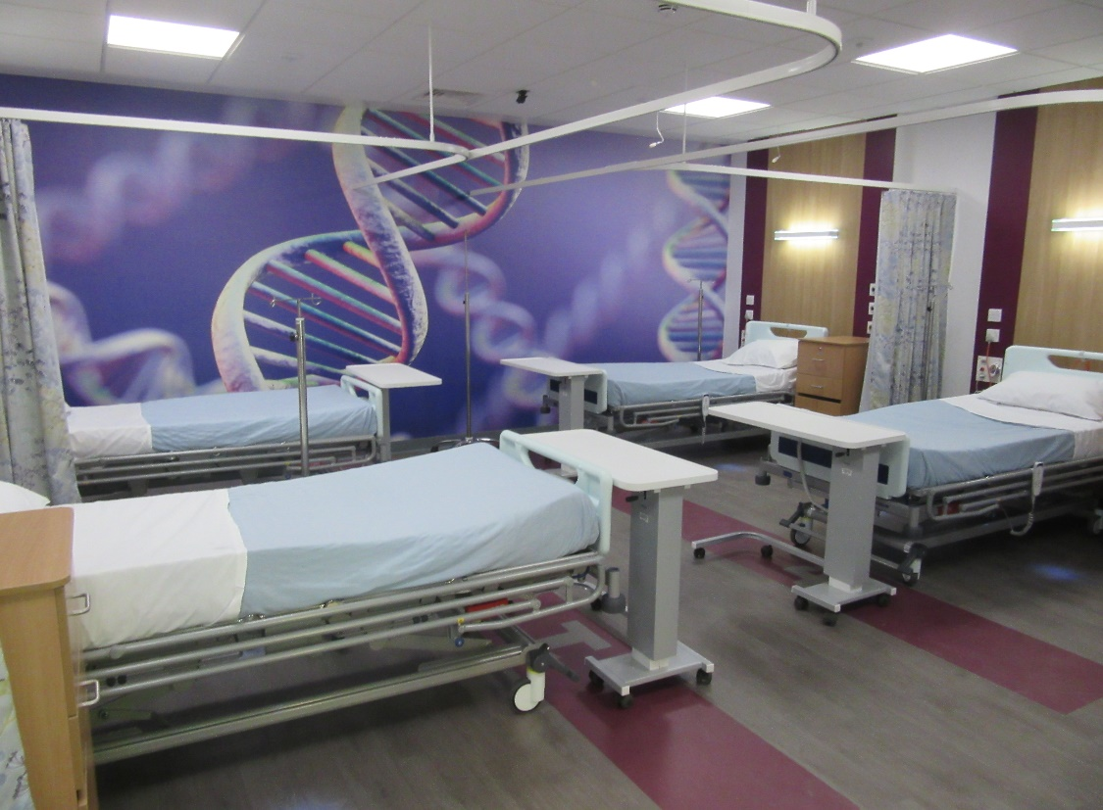
Simulated ward at LIFE, Chorley & South Ribble district hospital. Providing state of the art teaching environments
London.

Academic and background criteria for the Programme

Essential criteria
To apply for PWAP you MUST meet all the essential criteria:-
1. You are in Year 12 (lower sixth) in a state-maintained post 16 institution.
2. You attended a state high school (did not have to pay for your education).
4. We require at least seven GCSEs at grade A (7) or A* (8+).
English Language, Mathematics and at least two science subjects are required at GCSE minimum grade B(6). If Dual Award Science or Core and Additional Science are offered, the minimum required is BB(66).
A-Level required topics are:
Chemistry or Biology/Human Biology; and
One of the following subjects from Chemistry; Biology/Human Biology; Physics; Psychology; Mathematics or Further Mathematics;
A combination of three sciences is equally acceptable at A-level. However, our offer will not include combinations of very similar subjects, for example, Biology and Human Biology or Maths and Further Maths together.

In addition to the essential criteria, you will need at least one of the following socio-economic or personal background priority criteria.
Socio-economic background
Socio-economic background refers to where you live, study and the financial support you may have received.
We prioritise students who meet the following:
- Live in a neighbourhood that has a low progression rate to higher education or an area that has a high level of financial, social or economic deprivation. Check your postcode on our contextual admissions page;
- Receive discretionary learner payments/16–19 bursary/free school meals (FSM) at your current college;
- Received pupil premium or FSM at secondary school;
- Attended a high school where the average Key Stage 4 performance is lower than the national average;
- Attend a school or college where Key Stage 5 performance is lower than the national average.
You can check your secondary school and current school or college key performance data for Key Stage 4/5 at https://www.manchester.ac.uk/study/undergraduate/contextual-admissions/admissions/eligibility-2023/

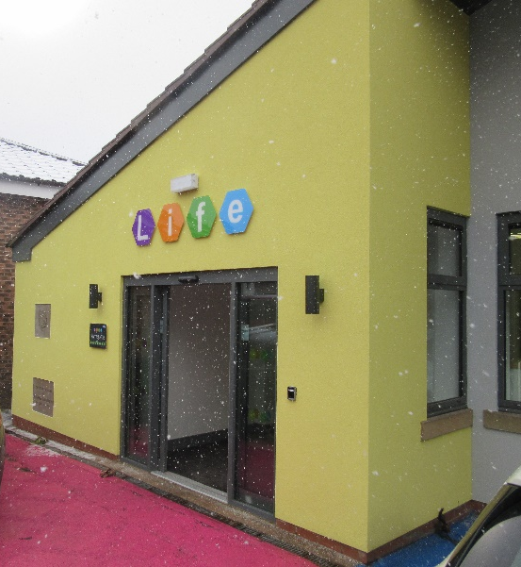
Additional consideration may be given to the following applicants;
- Whether you've been ‘looked after’ or ‘in care’ for more than three months.
You'll be asked this on your UCAS form and should answer 'yes' if you've spent time in local authority care living with foster carers or in a children's home.
- Whether you have refugee status.

LIFE, Chorley & South Ribble district hospital

What is involved in the Programme? |  | What will I get from the programme? |  |  |  |  | How do I apply?
You will attend timetabled sessions that will assist your application to study Medicine at the University of Manchester. These taster sessions will include learning clinical skills, communication skills and ethics. There will also be opportunity to find out about medical school assessments. The teaching will be delivered from 3pm until 5pm on Wednesdays and run between January 2024 and July 2024. The programme requires 100% commitment and attendance. |  | The programme will provide you with the knowledge, skills and experience which will be useful for the application and interview process to study medicine at the University of Manchester.  On successful completion of PWAP, you will be awarded a certificate of achievement that you can include in any supporting evidence in applications to any University. |  |  |  |  | You can access the application documents from your college tutor or directly from us via  Widening.Participation@lthtr.nhs.uk  from 30th October 2023 and return completed applications to us by 5th January 2024.  If you do not live in the Preston/Chorley area and cannot attend our face-to-face sessions, we can offer you the opportunity to attend our Lancashire Access Medics (LAM) which offers the same opportunities as PWAP.  Contact the above email address for further details.

